FACULTY EVALUATION
Programme Name: SBVP ALUMNI MASTERCLASS Online s Module 2 Kenya: (4th May 2026 - 8th May 2026)
Session: From Impact Measures to Long Term Sustainability Planning
Faculty Name: Dr. Mary Moraa Aminga
No. of Respondents: 16
No. of Participants: 16
Evaluation Parameter | (%) Individual Score | (%) Programme Average
Punctuality (Commencement and Completion of Sessions) | 98 | 95
How well do you understand the core concepts presented? | 88 | 90
Rate your confidence in applying the new skills learnt | 86 | 85
Degree of Faculty preparedness for the sessions | 99 | 96
Content and methodology of the program | 92 | 93
Quality of class and group discussions | 88 | 90
The information presented in the course is relevant to my work (ministry) | 94 | 94
Average scores | 92 | 92

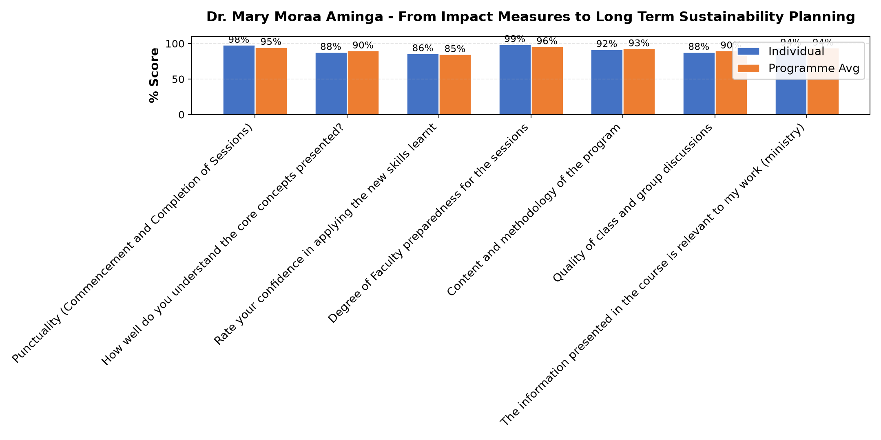

Comments & Feedback
- • I need someone to mentor me at the start-up time.
- • Limited resources for growth strategy
- • Financial instability
- • Insufficient resources
- • The unfinished projects that we are still working on
- • Excellent
- • Resources and Poor planning
SUBMITTED THROUGH:
SBS Evaluation Automation System

